# ANDROID STUDIO- JAVA

In android studio

Help -> Keymap reference – download it and reference

# Log

1. Import Log

import android.util.Log;

1. Declare a variable for string

private static final String *TAG* = "MY STRING";

1. Display message

Log.*i*(*TAG*, "onCreate");

Complete code

package com.example.a1helloworld;  
  
import androidx.appcompat.app.AppCompatActivity;  
import android.util.Log;  
  
import android.os.Bundle;  
  
public class MainActivity extends AppCompatActivity {  
  
 private static final String *TAG* = "MY STRING";  
  
 @Override  
 protected void onCreate(Bundle savedInstanceState) {  
 super.onCreate(savedInstanceState);  
 setContentView(R.layout.*activity_main*);  
  
 Log.*i*(*TAG*, "onCreate");  
 }  
}

# Life Cycle

1. In AppCompatActivity -> Cntrl + O
2. Search onStart method

package com.example.a1helloworld;  
  
import androidx.appcompat.app.AppCompatActivity;  
import android.util.Log;  
  
import android.os.Bundle;  
  
public class MainActivity extends AppCompatActivity {  
  
 private static final String *TAG* = " My_message";  
  
 @Override  
 protected void onCreate(Bundle savedInstanceState) {  
 super.onCreate(savedInstanceState);  
 setContentView(R.layout.*activity_main*);  
  
 Log.*i*(*TAG*, "onCreate");  
 }  
  
 @Override  
 protected void onStart() {  
 super.onStart();  
 Log.*i*(*TAG*, "onStart");  
 }  
  
 @Override  
 protected void onResume() {  
 super.onResume();  
  
 Log.*i*(*TAG*, "onResume");  
 }  
  
 @Override  
 protected void onPause() {  
 super.onPause();  
 Log.*i*(*TAG*, "onPause");  
 }  
  
 @Override  
 protected void onStop() {  
 super.onStop();  
 Log.*i*(*TAG*, "onStop");  
 }  
  
 @Override  
 protected void onRestart() {  
 super.onRestart();  
 Log.*i*(*TAG*, "onRestart");  
 }  
}

1. click logcat in bottom left corner of android studio
2. choose edit filter in options tag

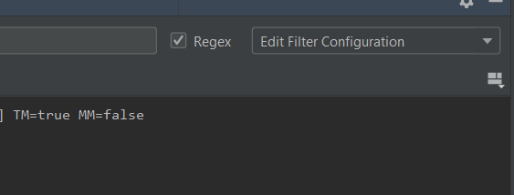

1. create a filter

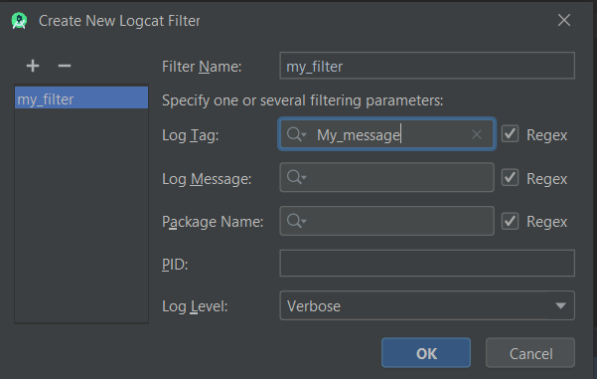

Output

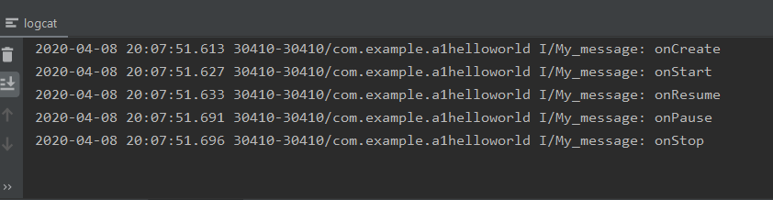

# Simple APP

<https://www.youtube.com/watch?v=Kpyf6s-vPxg&list=PLknSwrodgQ72X4sKpzf5vT8kY80HKcUSe&index=12>

## Create Login page UI

<?xml version="1.0" encoding="utf-8"?>  
<RelativeLayout xmlns:android="http://schemas.android.com/apk/res/android"  
 xmlns:app="http://schemas.android.com/apk/res-auto"  
 xmlns:tools="http://schemas.android.com/tools"  
 android:layout_width="match_parent"  
 android:layout_height="match_parent"  
 android:orientation="vertical"  
 tools:context=".MainActivity">  
  
 <TextView  
 android:id="@+id/textView"  
 android:layout_width="match_parent"  
 android:layout_height="wrap_content"  
 android:text="Login"  
 android:textAlignment="center"  
 android:textSize="30sp" />  
  
 <EditText  
 android:id="@+id/editTextEmail"  
 android:layout_below="@+id/textView"  
 android:layout_width="match_parent"  
 android:layout_height="wrap_content"  
 android:ems="10"  
 android:hint="Email"  
 android:inputType="textEmailAddress" />  
 <EditText  
 android:id="@+id/editTextPass"  
 android:layout_below="@+id/editTextEmail"  
 android:layout_width="match_parent"  
 android:layout_height="wrap_content"  
 android:ems="10"  
 android:hint="Password"  
 android:inputType="numberPassword" />  
 <Button  
 android:id="@+id/submitBtn"  
 android:layout_width="match_parent"  
 android:layout_height="wrap_content"  
 android:text="Submit"  
 android:layout_below="@+id/editTextPass"  
 />  
</RelativeLayout>

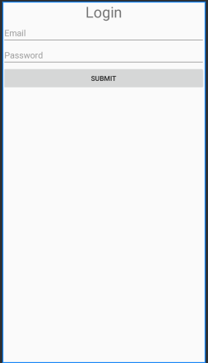

# Create UI using java

<https://www.youtube.com/watch?v=Z8hiM9LEANU&list=PLknSwrodgQ72X4sKpzf5vT8kY80HKcUSe&index=13>

1. import

import android.app.Activity;  
  
import android.os.Bundle;  
import android.widget.RelativeLayout;  
import android.widget.Button;

1. initialize object

public class MainActivity extends Activity {  
  
 @Override  
 protected void onCreate(Bundle savedInstanceState) {  
 super.onCreate(savedInstanceState);  
 setContentView(R.layout.*activity_main*);  
   
 RelativeLayout myRelLayout = new RelativeLayout(this);  
 Button myBtn = new Button(this);  
 }  
}

complete code

package com.example.a2ui;  
  
import android.app.Activity;  
  
import android.os.Bundle;  
import android.widget.RelativeLayout;  
import android.widget.Button;  
  
public class MainActivity extends Activity {  
  
 @Override  
 protected void onCreate(Bundle savedInstanceState) {  
 super.onCreate(savedInstanceState);  
  
  
 RelativeLayout myRelLayout = new RelativeLayout(this);  
 Button myBtn = new Button(this);  
 myRelLayout.addView(myBtn);  
 setContentView(myRelLayout);  
 }  
}

## Add properties to widget

<https://www.youtube.com/watch?v=9YCXCMzEMpo&list=PLknSwrodgQ72X4sKpzf5vT8kY80HKcUSe&index=14>

1. import color

complete code

package com.example.a2ui;  
  
import android.app.Activity;  
  
import android.os.Bundle;  
import android.widget.RelativeLayout;  
import android.widget.Button;  
import android.graphics.Color;  
  
public class MainActivity extends Activity {  
  
 @Override  
 protected void onCreate(Bundle savedInstanceState) {  
 super.onCreate(savedInstanceState);  
  
  
 RelativeLayout myRelLayout = new RelativeLayout(this);  
 myRelLayout.setBackgroundColor(Color.*BLUE*);  
 Button myBtn = new Button(this);  
 myBtn.setBackgroundColor(Color.*GREEN*);  
 myBtn.setText("Click me");  
 myRelLayout.addView(myBtn);  
 setContentView(myRelLayout);  
 }  
}

1. add params

RelativeLayout.LayoutParams btnDetails = new RelativeLayout.LayoutParams(  
 RelativeLayout.LayoutParams.*WRAP_CONTENT*,  
 RelativeLayout.LayoutParams.*WRAP_CONTENT*);  
btnDetails.addRule(RelativeLayout.*CENTER_HORIZONTAL*);  
btnDetails.addRule(RelativeLayout.*CENTER_VERTICAL*);  
  
myRelLayout.addView(myBtn, btnDetails);

Complete code

package com.example.a2ui;  
  
import android.app.Activity;  
  
import android.os.Bundle;  
import android.widget.RelativeLayout;  
import android.widget.Button;  
import android.graphics.Color;  
  
public class MainActivity extends Activity {  
  
 @Override  
 protected void onCreate(Bundle savedInstanceState) {  
 super.onCreate(savedInstanceState);  
  
  
 RelativeLayout myRelLayout = new RelativeLayout(this);  
 myRelLayout.setBackgroundColor(Color.*BLUE*);  
 Button myBtn = new Button(this);  
 myBtn.setBackgroundColor(Color.*GREEN*);  
 myBtn.setText("Click me");  
  
 setContentView(myRelLayout);  
  
 RelativeLayout.LayoutParams btnDetails = new RelativeLayout.LayoutParams(  
 RelativeLayout.LayoutParams.*WRAP_CONTENT*,  
 RelativeLayout.LayoutParams.*WRAP_CONTENT* );  
 btnDetails.addRule(RelativeLayout.*CENTER_HORIZONTAL*);  
 btnDetails.addRule(RelativeLayout.*CENTER_VERTICAL*);  
  
 myRelLayout.addView(myBtn, btnDetails);  
 }  
}

1. create edit text

package com.example.a2ui;  
  
import android.app.Activity;  
  
import android.os.Bundle;  
import android.widget.EditText;  
import android.widget.RelativeLayout;  
import android.widget.Button;  
import android.graphics.Color;  
import android.widget.EditText;  
  
public class MainActivity extends Activity {  
  
 @Override  
 protected void onCreate(Bundle savedInstanceState) {  
 super.onCreate(savedInstanceState);  
  
  
 RelativeLayout myRelLayout = new RelativeLayout(this);  
 myRelLayout.setBackgroundColor(Color.*BLUE*);  
 Button myBtn = new Button(this);  
 myBtn.setBackgroundColor(Color.*GREEN*);  
 myBtn.setText("Click me");  
  
 setContentView(myRelLayout);  
  
 RelativeLayout.LayoutParams btnDetails = new RelativeLayout.LayoutParams(  
 RelativeLayout.LayoutParams.*WRAP_CONTENT*,  
 RelativeLayout.LayoutParams.*WRAP_CONTENT* );  
 btnDetails.addRule(RelativeLayout.*CENTER_HORIZONTAL*);  
 btnDetails.addRule(RelativeLayout.*CENTER_VERTICAL*);  
  
 myRelLayout.addView(myBtn, btnDetails);  
  
 EditText username = new EditText(this);  
  
 myBtn.setId(1);  
 username.setId(2);  
 RelativeLayout.LayoutParams usernameDetails = new RelativeLayout.LayoutParams(  
 RelativeLayout.LayoutParams.*WRAP_CONTENT*,  
 RelativeLayout.LayoutParams.*WRAP_CONTENT* );  
  
 usernameDetails.addRule(RelativeLayout.*ABOVE*, myBtn.getId());  
 usernameDetails.addRule(RelativeLayout.*CENTER_HORIZONTAL*);  
 usernameDetails.setMargins(0,0,0,50);  
 myRelLayout.addView(username, usernameDetails);  
 }  
}

## DIP to pixels

<https://www.youtube.com/watch?v=Fw6pnAyQECE&list=PLknSwrodgQ72X4sKpzf5vT8kY80HKcUSe&index=16>

1. import

import android.content.res.Resources;  
import android.util.TypedValue;

1. calculate pixel

Resources r = getResources();  
int px = (int) TypedValue.*applyDimension*(TypedValue.*COMPLEX_UNIT_DIP*, 200, r.getDisplayMetrics());  
username.setWidth(px);

Complete code

package com.example.a2ui;  
  
import android.app.Activity;  
  
import android.os.Bundle;  
import android.widget.EditText;  
import android.widget.RelativeLayout;  
import android.widget.Button;  
import android.graphics.Color;  
import android.content.res.Resources;  
import android.util.TypedValue;  
  
public class MainActivity extends Activity {  
  
 @Override  
 protected void onCreate(Bundle savedInstanceState) {  
 super.onCreate(savedInstanceState);  
  
  
 RelativeLayout myRelLayout = new RelativeLayout(this);  
 myRelLayout.setBackgroundColor(Color.*BLUE*);  
 Button myBtn = new Button(this);  
 myBtn.setBackgroundColor(Color.*GREEN*);  
 myBtn.setText("Click me");  
  
 setContentView(myRelLayout);  
  
 RelativeLayout.LayoutParams btnDetails = new RelativeLayout.LayoutParams(  
 RelativeLayout.LayoutParams.*WRAP_CONTENT*,  
 RelativeLayout.LayoutParams.*WRAP_CONTENT* );  
 btnDetails.addRule(RelativeLayout.*CENTER_HORIZONTAL*);  
 btnDetails.addRule(RelativeLayout.*CENTER_VERTICAL*);  
  
 myRelLayout.addView(myBtn, btnDetails);  
  
 EditText username = new EditText(this);  
  
 myBtn.setId(1);  
 username.setId(2);  
 RelativeLayout.LayoutParams usernameDetails = new RelativeLayout.LayoutParams(  
 RelativeLayout.LayoutParams.*WRAP_CONTENT*,  
 RelativeLayout.LayoutParams.*WRAP_CONTENT* );  
  
 Resources r = getResources();  
 int px = (int) TypedValue.*applyDimension*(TypedValue.*COMPLEX_UNIT_DIP*, 200, r.getDisplayMetrics());  
 username.setWidth(px);  
  
 usernameDetails.addRule(RelativeLayout.*ABOVE*, myBtn.getId());  
 usernameDetails.addRule(RelativeLayout.*CENTER_HORIZONTAL*);  
 usernameDetails.setMargins(0,0,0,50);  
 myRelLayout.addView(username, usernameDetails);  
  
  
 }  
}

## Grid layout

<https://www.youtube.com/watch?v=DAcqmiPcXds&list=PLknSwrodgQ72X4sKpzf5vT8kY80HKcUSe&index=17>

## Event Handler

<https://www.youtube.com/watch?v=DAcqmiPcXds&list=PLknSwrodgQ72X4sKpzf5vT8kY80HKcUSe&index=17>

### Event Listner and callback method

MainActivity.java

Button mybtn = (Button) findViewById(R.id.*button*);  
mybtn.setOnClickListener(new View.OnClickListener() {  
 @Override  
 public void onClick(View v) {  
 Toast.*makeText*(MainActivity.this, "Btn clicked...", Toast.*LENGTH_SHORT*).show();  
 }  
});

Activity_main.xml

<?xml version="1.0" encoding="utf-8"?>  
<RelativeLayout xmlns:android="http://schemas.android.com/apk/res/android"  
 xmlns:app="http://schemas.android.com/apk/res-auto"  
 xmlns:tools="http://schemas.android.com/tools"  
 android:layout_width="match_parent"  
 android:layout_height="match_parent"  
 android:orientation="vertical"  
 tools:context=".MainActivity">  
  
 <Button  
 android:id="@+id/button"  
 android:layout_width="wrap_content"  
 android:layout_height="wrap_content"  
 android:layout_centerHorizontal="true"  
 android:layout_centerVertical="true"  
 android:text="Button" />  
</RelativeLayout>

## Multiple Event Listners

### Onclick & Onlong click listner

MainActivity.java

package com.example.a2ui;  
  
import android.app.Activity;  
  
import android.os.Bundle;  
import android.view.View;  
import android.widget.Button;  
import android.widget.Toast;  
  
public class MainActivity extends Activity {  
  
 @Override  
 protected void onCreate(Bundle savedInstanceState) {  
 super.onCreate(savedInstanceState);  
 setContentView(R.layout.*activity_main*);  
  
 Button mybtn = (Button) findViewById(R.id.*button*);  
 mybtn.setOnClickListener(new View.OnClickListener() {  
 @Override  
 public void onClick(View v) {  
 Toast.*makeText*(MainActivity.this, "Btn clicked...", Toast.*LENGTH_SHORT*).show();  
 }  
 });  
  
 mybtn.setOnLongClickListener(new View.OnLongClickListener() {  
 @Override  
 public boolean onLongClick(View v) {  
 Toast.*makeText*(MainActivity.this, "Btn long click.", Toast.*LENGTH_SHORT*).show();  
 return true;  
 }  
 });  
 }  
}

# Gestures

<https://www.youtube.com/watch?v=mb7C9cBrjDU&list=PLknSwrodgQ72X4sKpzf5vT8kY80HKcUSe&index=21>

activity_main.xml

<?xml version="1.0" encoding="utf-8"?>  
<RelativeLayout xmlns:android="http://schemas.android.com/apk/res/android"  
 xmlns:app="http://schemas.android.com/apk/res-auto"  
 xmlns:tools="http://schemas.android.com/tools"  
 android:layout_width="match_parent"  
 android:layout_height="match_parent"  
 android:orientation="vertical"  
 tools:context=".MainActivity">  
  
 <TextView  
 android:id="@+id/my_msg"  
 android:layout_width="wrap_content"  
 android:layout_height="wrap_content"  
 android:layout_centerHorizontal="true"  
 android:layout_centerVertical="true"  
 android:textSize="30dp"  
 android:text="My text" />  
</RelativeLayout>

MainActivity.java

package com.example.a2ui;  
  
import android.os.Bundle;  
import android.view.GestureDetector;  
import android.view.MotionEvent;  
import android.widget.TextView;  
import androidx.appcompat.app.AppCompatActivity;  
  
public class MainActivity extends AppCompatActivity implements GestureDetector.OnGestureListener, GestureDetector.OnDoubleTapListener {  
  
 private TextView my_msg;  
 private GestureDetector gestureDetector;  
  
 @Override  
 protected void onCreate(Bundle savedInstanceState) {  
 super.onCreate(savedInstanceState);  
 setContentView(R.layout.*activity_main*);  
  
 my_msg = (TextView) findViewById(R.id.*my_msg*);  
 this.gestureDetector = new GestureDetector(this, this);  
 gestureDetector.setOnDoubleTapListener(this);  
 }  
  
 @Override  
 public boolean onTouchEvent(MotionEvent event) {  
 this.gestureDetector.onTouchEvent(event);  
 return super.onTouchEvent(event);  
 }  
  
 @Override  
 public boolean onSingleTapConfirmed(MotionEvent e) {  
 my_msg.setText("onSingleTapConfirmed");  
 return true;  
 }  
  
 @Override  
 public boolean onDoubleTap(MotionEvent e) {  
 my_msg.setText("onDoubleTap");  
 return true;  
 }  
  
 @Override  
 public boolean onDoubleTapEvent(MotionEvent e) {  
 my_msg.setText("onDoubleTapEvent");  
 return true;  
 }  
  
 @Override  
 public boolean onDown(MotionEvent e) {  
 my_msg.setText("onDown");  
 return true;  
 }  
  
 @Override  
 public void onShowPress(MotionEvent e) {  
 my_msg.setText("onShowPress");  
  
 }  
  
 @Override  
 public boolean onSingleTapUp(MotionEvent e) {  
 my_msg.setText("onSingleTapUp");  
 return true;  
 }  
  
 @Override  
 public boolean onScroll(MotionEvent e1, MotionEvent e2, float distanceX, float distanceY) {  
 my_msg.setText("onScroll");  
 return true;  
 }  
  
 @Override  
 public void onLongPress(MotionEvent e) {  
 my_msg.setText("onLongPress");  
 }  
  
 @Override  
 public boolean onFling(MotionEvent e1, MotionEvent e2, float velocityX, float velocityY) {  
 my_msg.setText("onFling");  
 return true;  
 }  
}

# Fragments

<https://www.youtube.com/watch?v=ztbp59WSk-A&list=PLknSwrodgQ72X4sKpzf5vT8kY80HKcUSe&index=23>

1. paste image in : res > drawable (image name should not include capital letters or numbers)



1. create new layout file : right click layout folder -> new -> layout resource file

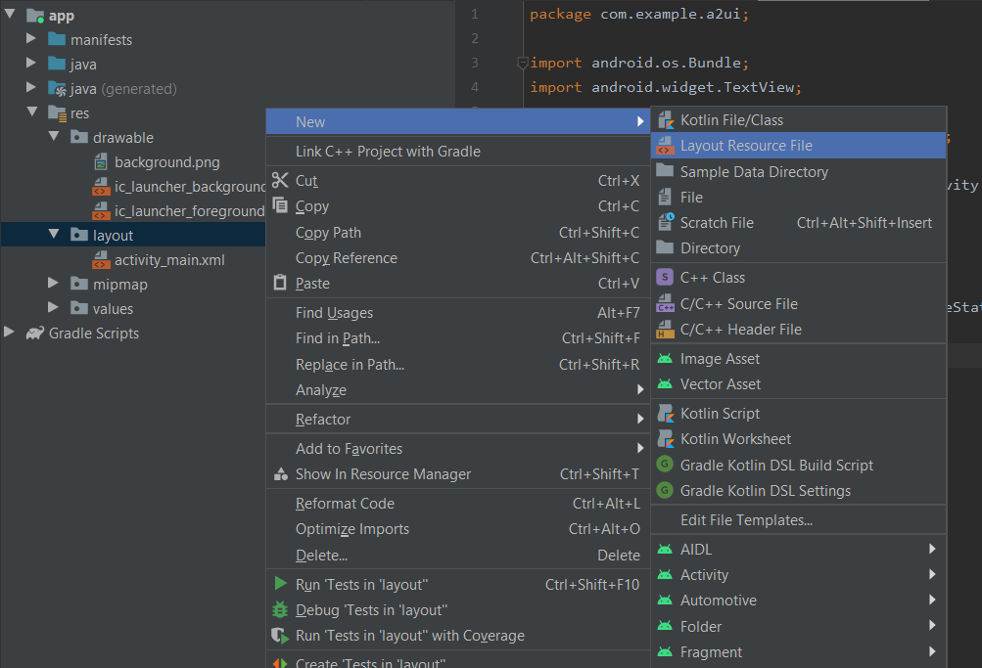

1. create layout (top_section_fragment & bottom_section_fragment)

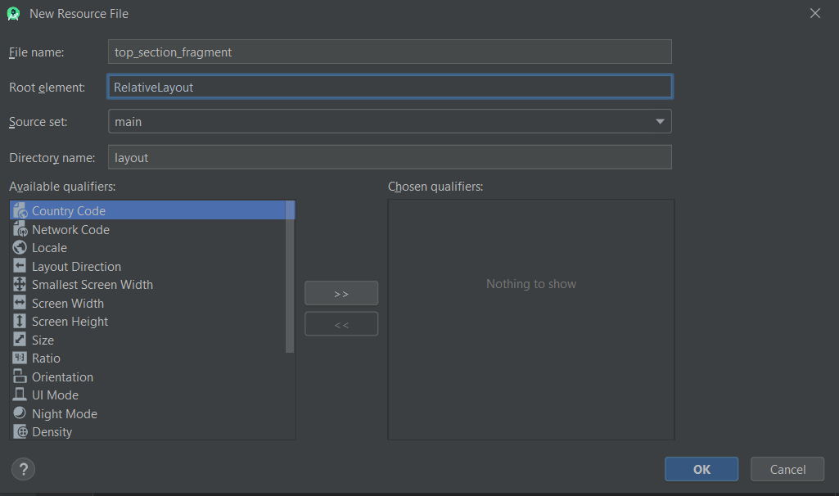

1. create jave class : java>com.example.appname (rightclick)>new > java class =(create two class – TopSectionFragment & BottomSectionFragment)

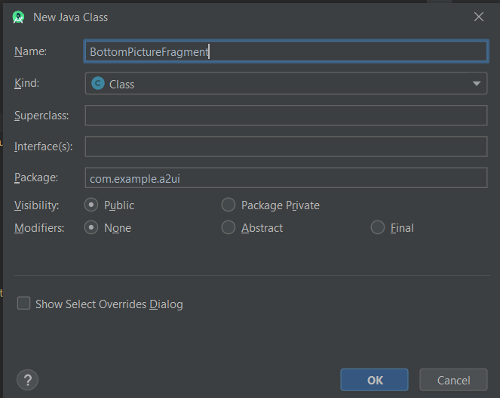

Activity_main.xml

1. drag and drop fragment

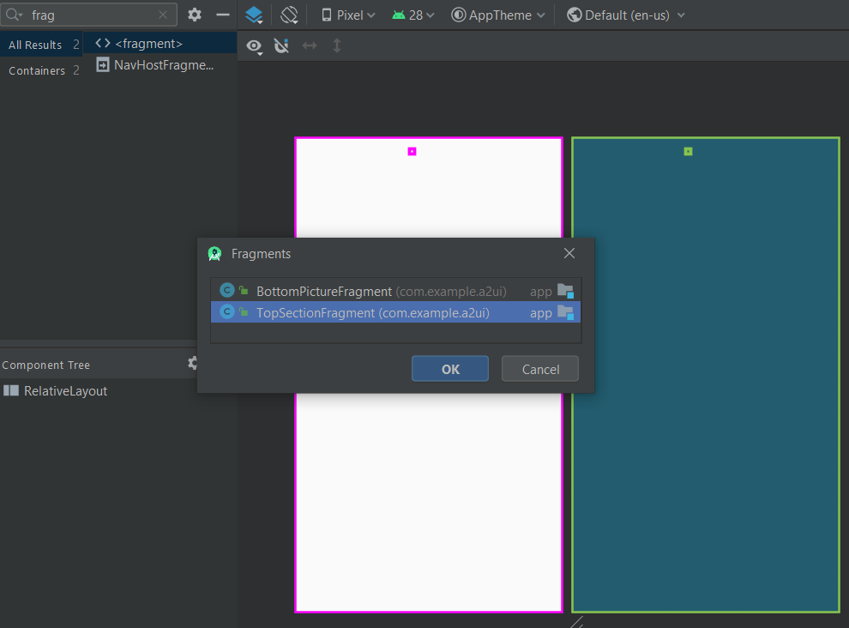

1. solve fragment error – select top_section_fragment

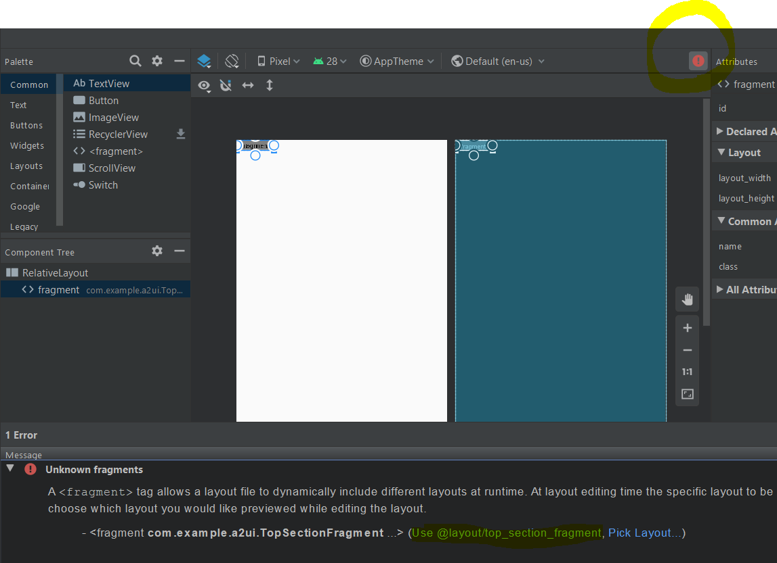

Top_section_fragment.xml

<?xml version="1.0" encoding="utf-8"?>  
<RelativeLayout xmlns:android="http://schemas.android.com/apk/res/android"  
 android:layout_width="match_parent" android:layout_height="match_parent">  
 <EditText  
 android:layout_width="wrap_content"  
 android:layout_height="wrap_content"  
 android:id="@+id/topTextInput"  
 android:layout_centerHorizontal="true"  
 android:layout_marginTop="15dp"  
 android:width="300dp"  
 />  
 <Button  
 android:layout_width="wrap_content"  
 android:layout_height="wrap_content"  
 android:id="@+id/button"  
 android:layout_marginTop="55dp"  
 android:layout_centerHorizontal="true"  
 android:text="Click me"  
 />  
</RelativeLayout>

TopSectionFragment.java

package com.example.a2ui;  
  
import android.os.Bundle;  
import android.view.LayoutInflater;  
import android.view.View;  
import android.view.ViewGroup;  
  
import androidx.annotation.NonNull;  
import androidx.annotation.Nullable;  
import androidx.fragment.app.Fragment;  
  
public class TopSectionFragment extends Fragment {  
 @Nullable  
 @Override  
 public View onCreateView(@NonNull LayoutInflater inflater, @Nullable ViewGroup container, @Nullable Bundle savedInstanceState) {  
 View view = inflater.inflate(R.layout.*top_section_fragment*, container, false);  
 return view;  
 }  
}

BottonPictureFragment.java

package com.example.a2ui;  
  
import android.os.Bundle;  
import android.view.LayoutInflater;  
import android.view.View;  
import android.view.ViewGroup;  
  
import androidx.annotation.NonNull;  
import androidx.annotation.Nullable;  
import androidx.fragment.app.Fragment;  
  
public class TopSectionFragment extends Fragment {  
 @Nullable  
 @Override  
 public View onCreateView(@NonNull LayoutInflater inflater, @Nullable ViewGroup container, @Nullable Bundle savedInstanceState) {  
 View view = inflater.inflate(R.layout.*top_section_fragment*, container, false);  
 return view;  
 }  
}

bottom_section_fragment.xml

<?xml version="1.0" encoding="utf-8"?>  
<RelativeLayout xmlns:android="http://schemas.android.com/apk/res/android"  
 android:layout_width="match_parent" android:layout_height="match_parent"  
 android:background="@drawable/background"  
 >  
  
</RelativeLayout>

Activity_main.xml

<?xml version="1.0" encoding="utf-8"?>  
<RelativeLayout xmlns:android="http://schemas.android.com/apk/res/android"  
 xmlns:app="http://schemas.android.com/apk/res-auto"  
 xmlns:tools="http://schemas.android.com/tools"  
 android:layout_width="match_parent"  
 android:layout_height="match_parent"  
 android:orientation="vertical"  
 tools:context=".MainActivity">  
  
  
 <fragment  
 android:id="@+id/fragment"  
 android:name="com.example.a2ui.TopSectionFragment"  
 android:layout_width="wrap_content"  
 android:layout_height="wrap_content"  
 tools:layout="@layout/top_section_fragment" />  
 <fragment  
 android:id="@+id/fragment2"  
 android:name="com.example.a2ui.BottomPictureFragment"  
 android:layout_width="wrap_content"  
 android:layout_height="wrap_content"  
 android:layout_below="@+id/fragment"  
 android:layout_marginTop="50dp"  
 tools:layout="@layout/bottom_section_fragment" />  
</RelativeLayout>

Output

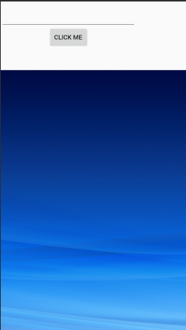

# WorkoutAdvisor – APP

<https://www.youtube.com/watch?v=8Js_Q0AWRLU&list=PLknSwrodgQ72X4sKpzf5vT8kY80HKcUSe&index=27>

1. empty activity

## spinner

Strings.xml

<string-array name="workout_types">  
 <item>Chest</item>  
 <item>Biceps</item>  
 <item>Triceps</item>  
 <item>Shoulders</item>  
</string-array>

Activity_main.xml

<Spinner  
 android:layout_width="wrap_content"  
 android:layout_height="wrap_content"  
 android:id="@+id/woroutType"  
 android:layout_marginTop="35dp"  
 android:layout_alignParentTop="true"  
 android:entries="@array/workout_types"  
 />

MainActivity.java

Spinner workouttype = (Spinner) findViewById(R.id.*woroutType*);  
String workout = String.*valueOf*(workouttype.getSelectedItem());

Complete code

MainActivity.java

package com.example.workoutadvisor2;  
  
import android.app.Activity;  
import android.os.Bundle;  
import android.view.View;  
import android.widget.Spinner;  
import android.widget.TextView;  
  
public class MainActivity extends Activity {  
  
 @Override  
 protected void onCreate(Bundle savedInstanceState) {  
 super.onCreate(savedInstanceState);  
 setContentView(R.layout.*activity_main*);  
 }  
  
 public void onClickFindWorkout(View view){  
 TextView textView = (TextView) findViewById(R.id.*workout*);  
 Spinner workouttype = (Spinner) findViewById(R.id.*woroutType*);  
 String workout = String.*valueOf*(workouttype.getSelectedItem());  
 textView.setText(workout);  
 }  
}

activity_main.xml

<?xml version="1.0" encoding="utf-8"?>  
<RelativeLayout xmlns:android="http://schemas.android.com/apk/res/android"  
 xmlns:app="http://schemas.android.com/apk/res-auto"  
 xmlns:tools="http://schemas.android.com/tools"  
 android:layout_width="match_parent"  
 android:layout_height="match_parent"  
 tools:context=".MainActivity">  
 <Spinner  
 android:layout_width="wrap_content"  
 android:layout_height="wrap_content"  
 android:id="@+id/woroutType"  
 android:layout_marginTop="35dp"  
 android:layout_alignParentTop="true"  
 android:entries="@array/workout_types"  
 />  
  
 <TextView  
 android:layout_width="wrap_content"  
 android:layout_height="wrap_content"  
 android:text="@string/workouts_here"  
 android:id="@+id/workout"  
 android:layout_below="@+id/findWorkout"  
 android:layout_centerHorizontal="true"  
 />  
 <Button  
 android:layout_width="wrap_content"  
 android:layout_height="wrap_content"  
 android:id="@+id/findWorkout"  
 android:layout_below="@+id/woroutType"  
 android:layout_centerHorizontal="true"  
 android:text="@string/click_me"  
 android:onClick="onClickFindWorkout"  
 />  
  
  
</RelativeLayout>

String.xml

<resources>  
 <string name="app_name">WorkoutAdvisor2</string>  
 <string name="workouts_here">Workouts Here</string>  
 <string name="click_me">Click me</string>  
 <string-array name="workout_types">  
 <item>Chest</item>  
 <item>Biceps</item>  
 <item>Triceps</item>  
 <item>Shoulders</item>  
 </string-array>  
</resources>

1. create WorkoutExpert java class
2. package com.example.workoutadvisor2;  
     
   import java.util.ArrayList;  
   import java.util.List;  
     
   public class WorkoutExpert {  
    List<String> getWorkouts (String workouttypes){  
    List <String> workout = new ArrayList<String>();  
    if (workouttypes.equals("Chest")){  
    workout.add("Bench Press");  
    workout.add("Cable Flys");  
    }  
    else if(workouttypes.equals("Triceps")){  
    workout.add("Triceps Ext");  
    workout.add("Triceps Push down");  
    }  
    else if(workouttypes.equals("Biceps")){  
    workout.add("Biceps Curls");  
    }  
    else if(workouttypes.equals("Sholder")){  
    workout.add("Sholder press");  
    }  
    return workout;  
    }  
   }

MainActivity.java

## Create an object – external java file

package com.example.workoutadvisor2;  
  
import android.app.Activity;  
import android.os.Bundle;  
import android.view.View;  
import android.widget.Spinner;  
import android.widget.TextView;  
  
import java.util.List;  
  
public class MainActivity extends Activity {  
  
 private WorkoutExpert workoutExpert = new WorkoutExpert();  
  
 @Override  
 protected void onCreate(Bundle savedInstanceState) {  
 super.onCreate(savedInstanceState);  
 setContentView(R.layout.*activity_main*);  
 }  
  
 public void onClickFindWorkout(View view){  
 TextView textView = (TextView) findViewById(R.id.*workout*);  
 Spinner workouttype = (Spinner) findViewById(R.id.*woroutType*);  
 String workout = String.*valueOf*(workouttype.getSelectedItem());  
// textView.setText(workout);  
 List<String> workoutList = workoutExpert.getWorkouts(workout);  
  
 StringBuilder workoutFormatter = new StringBuilder();  
 for(String work: workoutList){  
 workoutFormatter.append(work).append("\n");  
 }  
 textView.setText(workoutFormatter);  
 }  
  
}

# Overflow Menu

1. create new folder menu in res folder

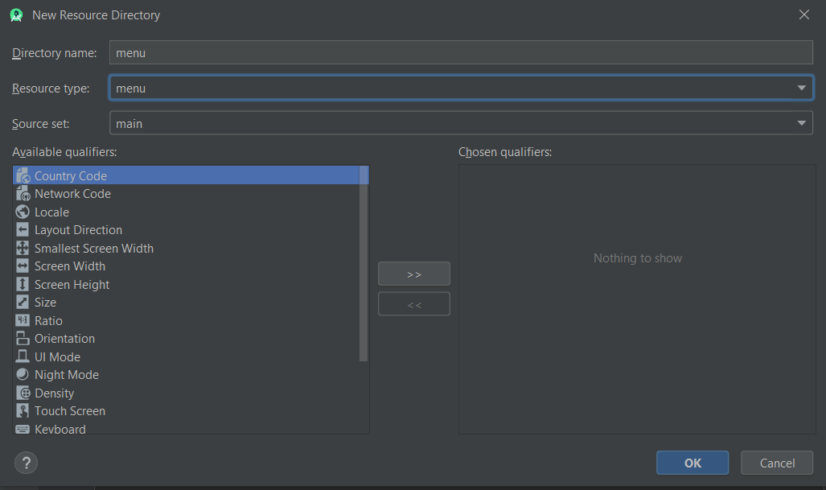

1. right click menu folder -> new -> menu resource file -> name it “menu_main”

<?xml version="1.0" encoding="utf-8"?>  
<menu xmlns:android="http://schemas.android.com/apk/res/android"  
 xmlns:app="http://schemas.android.com/apk/res-auto"  
 xmlns:tools="http://schemas.android.com/tools"  
 tools:context="com.example.overflowmenu.MainActivity">  
 <group android:checkableBehavior="single">  
 <item  
 android:id="@+id/menu_red"  
 android:orderInCategory="1"  
 app:showAsAction="never"  
 android:title="@string/red_string"  
 />  
 <item  
 android:id="@+id/menu_blue"  
 android:orderInCategory="2"  
 app:showAsAction="never"  
 android:title="@string/blue_string"  
 />  
 <item  
 android:id="@+id/menu_green"  
 android:orderInCategory="3"  
 app:showAsAction="never"  
 android:title="@string/green_string"  
 />  
 </group>  
  
</menu>

Strings.xml

<resources>  
 <string name="app_name">OverflowMenu</string>  
 <string name="red_string">Red</string>  
 <string name="blue_string">Blue</string>  
 <string name="green_string">Green</string>  
</resources>

MainActivity.java

package com.example.overflowmenu;  
  
import androidx.appcompat.app.AppCompatActivity;  
  
import android.graphics.Color;  
import android.os.Bundle;  
import android.view.Menu;  
import android.view.MenuItem;  
import android.widget.RelativeLayout;  
  
public class MainActivity extends AppCompatActivity {  
  
 @Override  
 protected void onCreate(Bundle savedInstanceState) {  
 super.onCreate(savedInstanceState);  
 setContentView(R.layout.*activity_main*);  
 }  
  
 @Override  
 public boolean onCreateOptionsMenu(Menu menu) {  
 getMenuInflater().inflate(R.menu.*menu_main*, menu);  
 return true;  
 }  
  
 @Override  
 public boolean onOptionsItemSelected(MenuItem item) {  
 RelativeLayout main_view = (RelativeLayout) findViewById(R.id.*main_view*);  
 switch (item.getItemId()){  
 case R.id.*menu_red*:  
 if(item.isChecked())  
 item.setChecked(false);  
 else item.setChecked(true);  
 main_view.setBackgroundColor(Color.*RED*);  
 return true;  
 case R.id.*menu_blue*:  
 if(item.isChecked())  
 item.setChecked(false);  
 else item.setChecked(true);  
 main_view.setBackgroundColor(Color.*BLUE*);  
 return true;  
 case R.id.*menu_green*:  
 if(item.isChecked())  
 item.setChecked(false);  
 else item.setChecked(true);  
 main_view.setBackgroundColor(Color.*GREEN*);  
 return true;  
 default: return super.onOptionsItemSelected(item);  
 }  
 }  
}

# Animation and transition

<https://www.youtube.com/watch?v=ZAsknWvR09E&list=PLknSwrodgQ72X4sKpzf5vT8kY80HKcUSe&index=34>

MainActivity.java

package com.example.overflowmenu;  
  
import androidx.appcompat.app.AppCompatActivity;  
  
import android.graphics.Color;  
import android.os.Bundle;  
import android.transition.TransitionManager;  
import android.view.Menu;  
import android.view.MenuItem;  
import android.view.MotionEvent;  
import android.view.View;  
import android.view.ViewGroup;  
import android.widget.RelativeLayout;  
  
public class MainActivity extends AppCompatActivity {  
  
 ViewGroup myLayout;  
  
 @Override  
 protected void onCreate(Bundle savedInstanceState) {  
 super.onCreate(savedInstanceState);  
 setContentView(R.layout.*activity_main*);  
  
 myLayout = (ViewGroup) findViewById(R.id.*main_view*);  
 myLayout.setOnTouchListener(new View.OnTouchListener() {  
 @Override  
 public boolean onTouch(View v, MotionEvent event) {  
 moveButton();  
 return true;  
 }  
 });  
 }  
  
 private void moveButton() {  
 TransitionManager.*beginDelayedTransition*(myLayout);  
 View myButton = findViewById(R.id.*button*);  
 RelativeLayout.LayoutParams positionRules = new RelativeLayout.LayoutParams(  
 RelativeLayout.LayoutParams.*WRAP_CONTENT*,  
 RelativeLayout.LayoutParams.*WRAP_CONTENT* );  
 positionRules.addRule(RelativeLayout.*ALIGN_PARENT_BOTTOM*, RelativeLayout.*TRUE*);  
 myButton.setLayoutParams(positionRules);  
  
// code for expanding the button  
 ViewGroup.LayoutParams sizeRules = myButton.getLayoutParams();  
 sizeRules.width = 450;  
 sizeRules.height = 300;  
 myButton.setLayoutParams(sizeRules);  
 }  
  
  
}

activity_main.xml

<?xml version="1.0" encoding="utf-8"?>  
<RelativeLayout xmlns:android="http://schemas.android.com/apk/res/android"  
 xmlns:app="http://schemas.android.com/apk/res-auto"  
 xmlns:tools="http://schemas.android.com/tools"  
 android:layout_width="match_parent"  
 android:layout_height="match_parent"  
 android:id="@+id/main_view"  
 tools:context=".MainActivity">  
  
 <Button  
 android:layout_width="wrap_content"  
 android:layout_height="wrap_content"  
 android:id="@+id/button"  
 android:text="Animation"  
 />  
  
</RelativeLayout>

# Intent

<https://www.youtube.com/watch?v=pMMWo96j4JI&list=PLknSwrodgQ72X4sKpzf5vT8kY80HKcUSe&index=35>

1. create new activity: right click com.example.appname->new->Activity->empty activity
2. create intent

MainActivity.java

package com.example.overflowmenu;  
  
import androidx.appcompat.app.AppCompatActivity;  
import android.content.Intent;  
import android.os.Bundle;  
import android.view.View;  
  
public class MainActivity extends AppCompatActivity {  
  
  
 @Override  
 protected void onCreate(Bundle savedInstanceState) {  
 super.onCreate(savedInstanceState);  
 setContentView(R.layout.*activity_main*);  
  
 }  
  
 public void move2second(View view) {  
 Intent i = new Intent(this, Main2Activity.class);  
 startActivity(i);  
 }  
  
  
}

activity_main.xml

<?xml version="1.0" encoding="utf-8"?>  
<RelativeLayout xmlns:android="http://schemas.android.com/apk/res/android"  
 xmlns:app="http://schemas.android.com/apk/res-auto"  
 xmlns:tools="http://schemas.android.com/tools"  
 android:layout_width="match_parent"  
 android:layout_height="match_parent"  
 android:id="@+id/main_view"  
 tools:context=".MainActivity">  
  
 <Button  
 android:layout_width="wrap_content"  
 android:layout_height="wrap_content"  
 android:id="@+id/button"  
 android:text="Animation"  
 android:onClick="move2second"  
 />  
  
</RelativeLayout>

## Send data

<https://www.youtube.com/watch?v=-GxReMxnXkQ&list=PLknSwrodgQ72X4sKpzf5vT8kY80HKcUSe&index=36>

MainActivity.java

Intent i = new Intent(this, Main2Activity.class);  
i.putExtra("mymsg", "Hello");  
startActivity(i);

Main2Activity.java

package com.example.overflowmenu;  
  
import androidx.appcompat.app.AppCompatActivity;  
  
import android.os.Bundle;  
import android.widget.Toast;  
  
public class Main2Activity extends AppCompatActivity {  
  
 @Override  
 protected void onCreate(Bundle savedInstanceState) {  
 super.onCreate(savedInstanceState);  
 setContentView(R.layout.*activity_main2*);  
  
 Bundle firstData = getIntent().getExtras();  
 if (firstData == null){  
 return;  
 }  
 String firstMsg = firstData.getString("mymsg");  
 Toast.*makeText*(this, firstMsg, Toast.*LENGTH_SHORT*).show();  
 }  
}

## Send Broadcast Intent – Not Working

<https://www.youtube.com/watch?v=uVpleldaTnU&list=PLknSwrodgQ72X4sKpzf5vT8kY80HKcUSe&index=37>

MainActivity.java

package com.example.overflowmenu;  
  
import androidx.appcompat.app.AppCompatActivity;  
import android.content.Intent;  
import android.os.Bundle;  
import android.view.View;  
  
public class MainActivity extends AppCompatActivity {  
  
  
 @Override  
 protected void onCreate(Bundle savedInstanceState) {  
 super.onCreate(savedInstanceState);  
 setContentView(R.layout.*activity_main*);  
  
 }  
  
 public void move2second(View view) {  
 Intent i = new Intent(this, Main2Activity.class);  
 i.setAction("com.example.overflowmenu");  
 i.addFlags(Intent.*FLAG_INCLUDE_STOPPED_PACKAGES*);  
 sendBroadcast(i);  
 }  
}

## BroadCastReceiver – Not Working

<https://www.youtube.com/watch?v=ys-ot3_Nc44&list=PLknSwrodgQ72X4sKpzf5vT8kY80HKcUSe&index=38>

1. create new – No activity
2. right click com.example.appname -> new -> other -> Broad cast receiver

AndroidManifest.xml

<?xml version="1.0" encoding="utf-8"?>  
<manifest xmlns:android="http://schemas.android.com/apk/res/android"  
 package="com.example.broadcastreceiver">  
  
 <application  
 android:allowBackup="true"  
 android:icon="@mipmap/ic_launcher"  
 android:label="@string/app_name"  
 android:roundIcon="@mipmap/ic_launcher_round"  
 android:supportsRtl="true"  
 android:theme="@style/AppTheme">  
 <receiver  
 android:name=".MyReceiver"  
 android:enabled="true"  
 android:exported="true">  
 <intent-filter>  
 <action android:name="com.example.overflowmenu">  
  
 </action>  
 </intent-filter>  
 </receiver>  
 </application>  
  
</manifest>

MyReceiver.java

package com.example.broadcastreceiver;  
  
import android.content.BroadcastReceiver;  
import android.content.Context;  
import android.content.Intent;  
import android.widget.Toast;  
  
public class MyReceiver extends BroadcastReceiver {  
  
 @Override  
 public void onReceive(Context context, Intent intent) {  
 // *TODO: This method is called when the BroadcastReceiver is receiving* // an Intent broadcast.  
 Toast.*makeText*(context, "Broadcast received..", Toast.*LENGTH_SHORT*).show();  
 }  
}

# Thread

<https://www.youtube.com/watch?v=FP71FR2T-Q4&list=PLknSwrodgQ72X4sKpzf5vT8kY80HKcUSe&index=39>

MainActivity.java

package com.example.thread;  
  
import androidx.appcompat.app.AppCompatActivity;  
  
import android.os.Bundle;  
import android.os.Handler;  
import android.os.Message;  
import android.view.View;  
import android.widget.TextView;  
  
public class MainActivity extends AppCompatActivity {  
  
 Handler handler = new Handler(){  
 @Override  
 public void handleMessage(Message msg) {  
 TextView mytextView = (TextView) findViewById(R.id.*textView*);  
 mytextView.setText("Button Clicked");  
 }  
 };  
  
 @Override  
 protected void onCreate(Bundle savedInstanceState) {  
 super.onCreate(savedInstanceState);  
 setContentView(R.layout.*activity_main*);  
 }  
 public void ClickMyButton(View view){  
 Runnable r = new Runnable() {  
 @Override  
 public void run() {  
 long futuretime = System.*currentTimeMillis*()+10000;  
 while (System.*currentTimeMillis*()< futuretime){  
 synchronized (this){  
 try{  
 wait(futuretime - System.*currentTimeMillis*());  
 }catch (Exception e){  
  
 }  
 }  
 }  
 handler.sendEmptyMessage(0);  
 }  
 };  
 Thread mythred = new Thread(r);  
 mythred.start();  
  
  
 }  
}

activity_main.xml

<?xml version="1.0" encoding="utf-8"?>  
<RelativeLayout xmlns:android="http://schemas.android.com/apk/res/android"  
 xmlns:app="http://schemas.android.com/apk/res-auto"  
 xmlns:tools="http://schemas.android.com/tools"  
 android:layout_width="match_parent"  
 android:layout_height="match_parent"  
 tools:context=".MainActivity">  
  
 <TextView  
 android:layout_width="wrap_content"  
 android:layout_height="wrap_content"  
 android:text="Hello World!"  
 android:layout_centerHorizontal="true"  
 android:id="@+id/textView"/>  
 <Button  
 android:layout_width="wrap_content"  
 android:layout_height="wrap_content"  
 android:id="@+id/button"  
 android:text="@string/click_me"  
 android:layout_centerHorizontal="true"  
 android:layout_below="@+id/textView"  
 android:onClick="ClickMyButton"  
 />  
  
</RelativeLayout>

# Intent Service

<https://www.youtube.com/watch?v=e04Mv9aju0w&list=PLknSwrodgQ72X4sKpzf5vT8kY80HKcUSe&index=41>

1. Create new class MyIntentServiece.java

package com.example.thread;  
  
import android.app.IntentService;  
import android.content.Intent;  
import android.widget.Toast;  
  
import androidx.annotation.Nullable;  
  
public class MyIntentServiece extends IntentService {  
 private static final String *TAG* = "com.example.thread";  
 public MyIntentServiece() {  
 super("MyIntentServiece");  
 }  
  
 @Override  
 protected void onHandleIntent(@Nullable Intent intent) {  
 Toast.*makeText*(this, "Serviece Started", Toast.*LENGTH_SHORT*).show();  
 }  
}

MainActivity.java

package com.example.thread;  
  
import androidx.appcompat.app.AppCompatActivity;  
  
import android.content.Intent;  
import android.os.Bundle;  
import android.view.View;  
  
public class MainActivity extends AppCompatActivity {  
  
  
 @Override  
 protected void onCreate(Bundle savedInstanceState) {  
 super.onCreate(savedInstanceState);  
 setContentView(R.layout.*activity_main*);  
  
 Intent intent = new Intent(this, MyIntentServiece.class);  
 startService(intent);  
 }  
 public void ClickMyButton(View view){  
  
 }  
}

AndroidManifest.xml

<?xml version="1.0" encoding="utf-8"?>  
<manifest xmlns:android="http://schemas.android.com/apk/res/android"  
 package="com.example.thread">  
  
 <application  
 android:allowBackup="true"  
 android:icon="@mipmap/ic_launcher"  
 android:label="@string/app_name"  
 android:roundIcon="@mipmap/ic_launcher_round"  
 android:supportsRtl="true"  
 android:theme="@style/AppTheme">  
 <activity android:name=".MainActivity">  
 <intent-filter>  
 <action android:name="android.intent.action.MAIN" />  
  
 <category android:name="android.intent.category.LAUNCHER" />  
 </intent-filter>  
 </activity>  
 <service android:name=".MyIntentServiece" />  
 </application>  
  
</manifest>

## Create service using service class

1. Right click com.example.thread -> new -> service -> Service (Not Intent service)

MyServiece.java

package com.example.thread;  
  
import android.app.Service;  
import android.content.Intent;  
import android.os.IBinder;  
import android.util.Log;  
import android.widget.Toast;  
  
public class MyService extends Service {  
 private static final String *TAG* = "com.example.thread";  
  
 public MyService() {  
 }  
  
 @Override  
 public int onStartCommand(Intent intent, int flags, int startId) {  
 Log.*i*(*TAG*, "OnStart called...");  
 Runnable r = new Runnable() {  
 @Override  
 public void run() {  
 for (int i=0; i<5; i++) {  
 long futuretime = System.*currentTimeMillis*() + 5000;  
 while (System.*currentTimeMillis*() < futuretime) {  
 synchronized (this) {  
 try {  
 wait(futuretime - System.*currentTimeMillis*());  
 Log.*i*(*TAG*, "Serviece is running...");  
 } catch (Exception e) {  
  
 }  
 }  
 }  
 }  
  
 }  
 };  
 Thread mythred = new Thread(r);  
 mythred.start();  
 return Service.*START_STICKY*;  
 }  
  
 @Override  
 public void onDestroy() {  
 Log.*i*(*TAG*, "onDestroy called...");  
 }  
  
 @Override  
 public IBinder onBind(Intent intent) {  
 return null;  
 }  
}

MainActivity.java

package com.example.thread;  
  
import androidx.appcompat.app.AppCompatActivity;  
  
import android.content.Intent;  
import android.os.Bundle;  
import android.view.View;  
  
public class MainActivity extends AppCompatActivity {  
  
  
 @Override  
 protected void onCreate(Bundle savedInstanceState) {  
 super.onCreate(savedInstanceState);  
 setContentView(R.layout.*activity_main*);  
  
 Intent intent = new Intent(this, MyService.class);  
 startService(intent);  
 }  
 public void ClickMyButton(View view){  
  
 }  
}

output

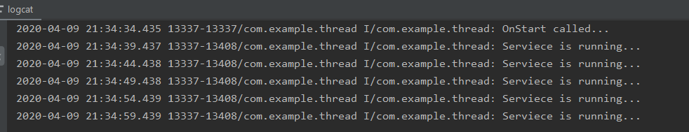

## Bound Service

<https://www.youtube.com/watch?v=Wy1cN57aCfM&list=PLknSwrodgQ72X4sKpzf5vT8kY80HKcUSe&index=43>

1. Right click com.example.appname -> new -> Service -> Service(not Intent Service)